1. Prepare a png image and add it to Unity Editor, click the image. In Inspector, change “TextureType” to “Sprite” and apply. If image is too large, adjust PixelsPerUnit.

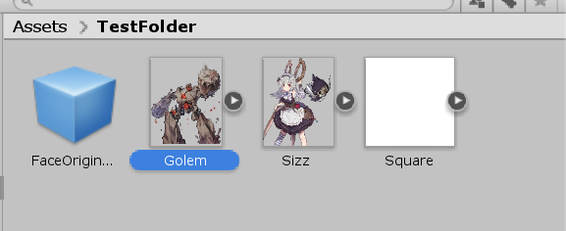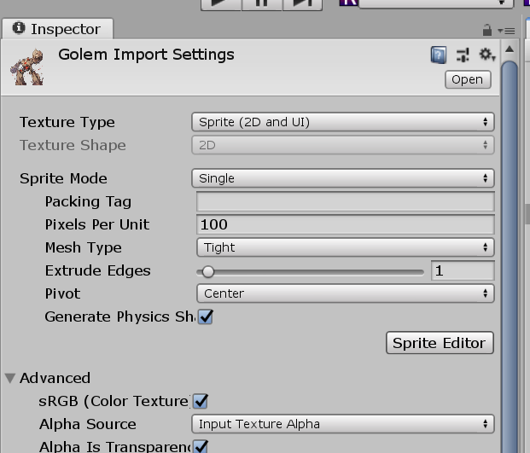

1. Click SpriteEditor in Inspector, move the circle to the middle bottom of the image, and save.

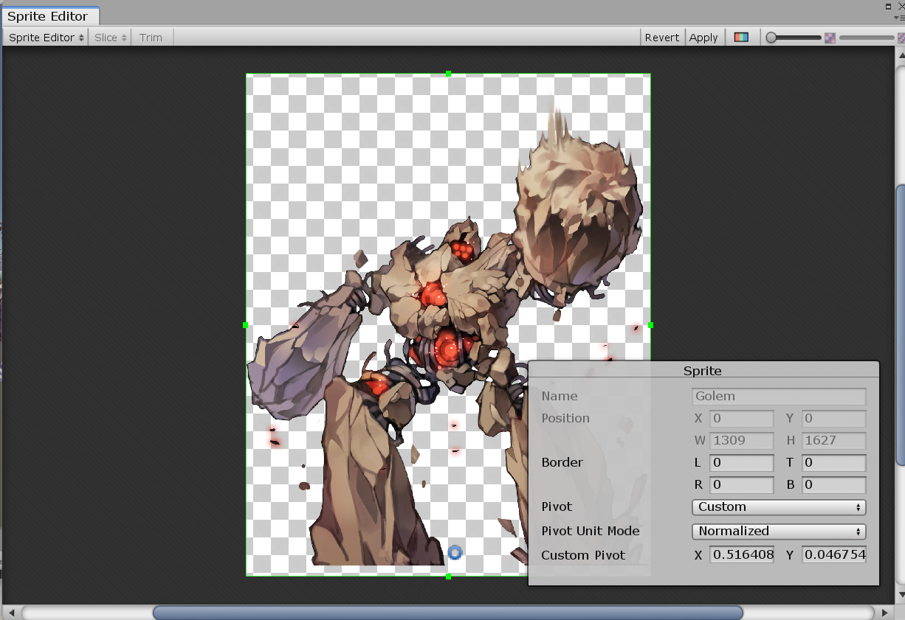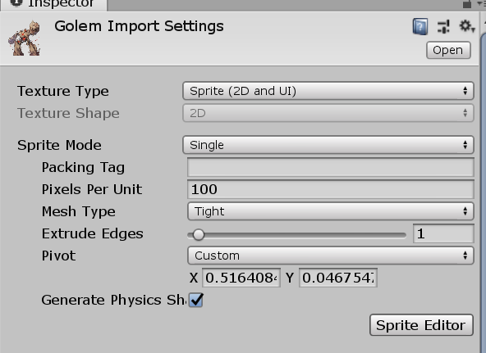

1. Create a GameObject and add SpriteRenderer component, change its layer to battleobject, and set the prepared image as its Sprite.

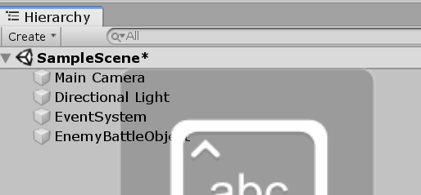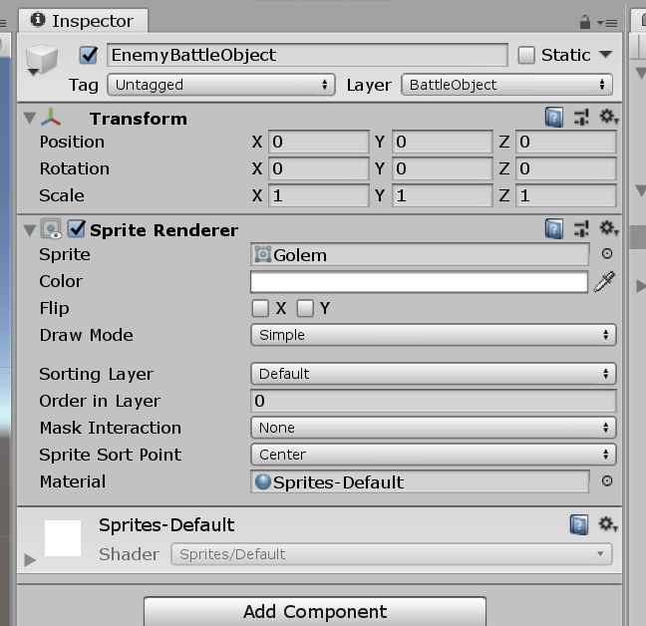

1. Under this GameObject create three children GameObjects. Put “Head” GameObject to the head of the image, put “Center” to the body of the image, put “UI” to the bottom where you want to show HP bar.

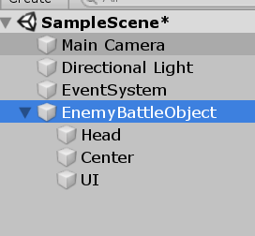

1. Create a component “EnemyCustom” in the main GameObject, and set its attributes as the corresponding children GameObject.

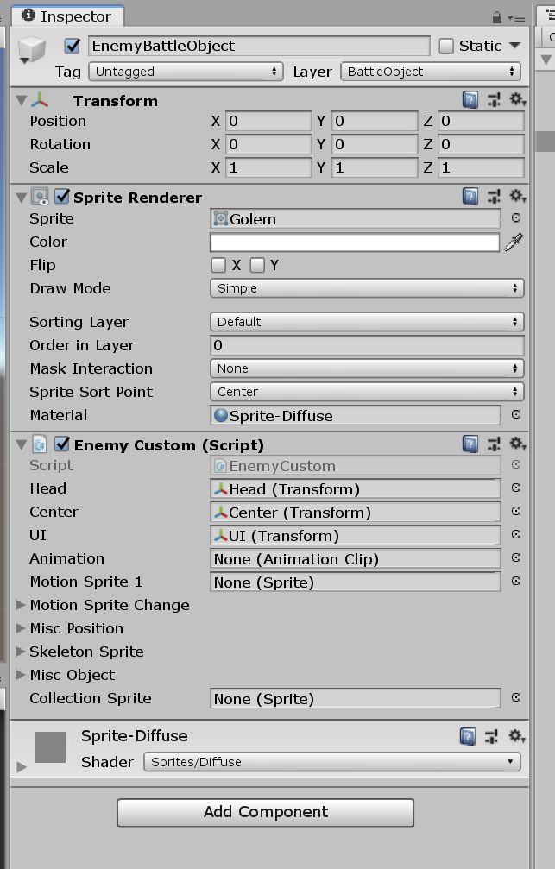

1. Create a component “Animation” in the main GameObject, in Project window create an “Animation” and set it as the attribute in the created component.

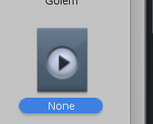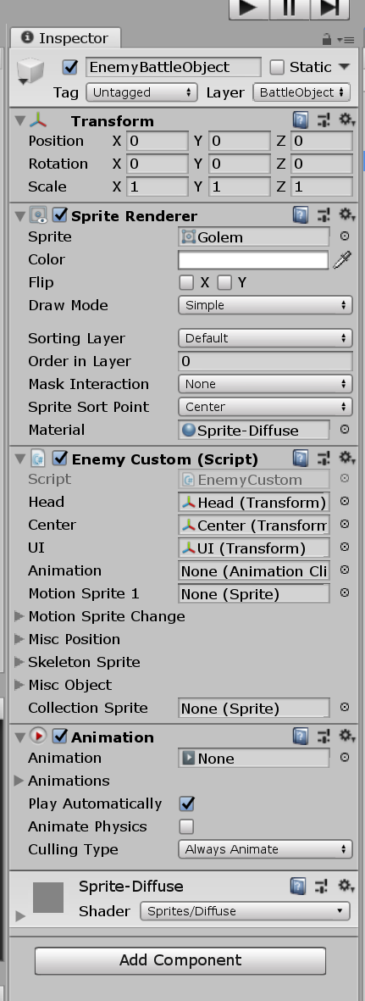

1. Drag the GameObject to Project window to create a prefab, which is ready to be packaged.

